# Q. How is the Disaster Risk Perception differ from various focus groups based on age, gender and disability?

Team: Bijay Krishna Upadhyay, Om Kala Khanal, Ram Shrestha, Sarmila Paudyal, Sushil Pandit

Derived from: Views from the Frontline 2019 (VFL 2019)

Paper Title: Disaster Risk Perception in the Middle Mountain Region of Nepal based on Age, Gender and Disability

# Disaster Risk Perception in the Middle Mountain Region of Nepal based on Age, Gender and Disability

# Abstract

# Key words

disaster, risk, risk perception, gender, age, persons with disability, Nepal

# Introduction

Disasters have had profound negative impacts on individuals, communities and societies. Disaster cause damage, disruption and casualties, and leaving the affected communities unable to function normally without outside assistance (Twigg, 2007). Whether man-made, resulting from some human activities such as chemical hazards, radioactive materials, explosions, fires, crashes, collapse etc. (Sena and Woldemichael, 2006) or the result of” a sudden ecological phenomenon” (Sena and Woldemichael, 2006:6), disasters creates sudden disruption in the community causing environmental, material, human and economic losses exceeding the capacity of the affected people to restore back to normal situation without external support (UNISDR, 2009). They exceed the capacity of community resources and assistance, victimized people need external assistance and resources such as food, shelter, clothing, medical and nursing and other essential facilities (Assar, 1971).

Yet, by the very nature of their complex origins, disasters are inherently uncertain and their effect uneven across societies. Disasters include conditions in which the outcomes and probabilities, or at least the probabilities are unknown (Meder, Le Lec, & Osman, 2013). Moreover, disaster risk, which according to the United Nations Disaster Risk Reduction (2009) is “the potential disaster losses, in lives, health status, livelihoods, assets and services which could occur to the particular community or a society over some specific future time period,” is not uniform in society.

Social characteristics profoundly shape how likely an individual or group is to be negatively impacted in a disaster. Three especially salient social categories for vulnerability to disasters are gender, disability, and age.

Gender, which refers to the set of learned expectations, behaviors, and attitudes about being a man or woman from biologically determined traits (Rolleri, 2013), can shape an individual’s choice and actions in ways that increase or decrease their exposure and vulnerability to hazards. In the fishing communities, men traditionally owned the boat and go out for fishing whereas women wait their husband to come back at seashores. When the 2004 Indian Ocean Tsunami hit, women were waiting for their husband near seashores. When the tsunami passed through the deep water, it was relatively calm and the fishermen did not suspect much but women near seashores instantly became a large proportion of the Tsunami victim (Oxfam International, 2005). As per the natural disaster record, three times more women were killed by tsunami, globally (Hines, 2007).

People with disabilities – those with impairments, activity limitations and participation restrictions - are also more vulnerable to disasters and any other adverse situation. In case of sudden onset disasters that allow for little warning time, people with disabilities may need more time to do recommended protective actions, escaping. They may have more difficulty withstanding the force of disaster during earthquakes or tornados. For example, some people with disabilities may be unable to hike up a hill during flash flood or may not be able to run up to evacuation point on higher ground in the event of tsunami (Peek & Stough, 2010). Typically, the evacuation points are planned for the people having no mental and physical limitations. Sometimes people with disabilities may not recognized signs of impending environmental hazard or become confused when responding the emergency signals (Scotti et al., 2007).

Age too has been found to have a profound influence on vulnerability to hazards. Children belong to a highly vulnerable group due to their full dependence on parents or other adults. During disasters, children are emotionally and physically vulnerable. According to research, a wide range of social and environmental factors (Peek, 2008) create psychological, physical, and educational vulnerability during disasters. Along with children, elder people are also vulnerable to the disaster. With the increasing age of elder group, people get weak physically and mentally. They are also dependent to the adult. Elder group of people are also become disable with increasing age to hike up hill or run up to evacuation point.

These social characteristics of gender, disability and age also shape how individuals understand hazards and their own risks. Risk perception refers to the “subjective assessment of the probability of a specified type of accident happening and how concerned we are with the consequences” (Sjöberg, Moen, & Rundmo, 2004). Pidgeon, Hood, Jones, Turner, and Gibson (1992) defined risk perception as “people’s beliefs, attitudes, judgments and feelings, as well as the wider social or cultural values and dispositions that people adopt, towards hazards and their benefits.” Research over the last several decades has explored how social characteristics shape risk perception.

Research on gender and disasters have found that gender can influence risk perception. In the patriarchal society, women are thought to be the responsibilities of men and they need to be rescued by the men if there is disaster. But if the women are involved in local level DRR, they come to understand that they can take a lead role at all stages, including rescuing men during disaster. Equal participation of women in early warning system and other preparedness activities can reduce risk on them and also, they can rescue other (Fordham, 2006a)

Disability too can influence risk perception of natural and human-induced disasters. All people, even those with good physical and mental condition, are vulnerable during disaster and may experience temporary or permanent disability from the disaster. People with disability prior to a disaster are already vulnerable to disaster and may experience new or exacerbated mental or physical limitations. Even so, the needs of people with disabilities and those that may experience new disabilities are often not taken into account during disaster planning (Wisner et al., 2012).

People of different ages also have age-based perceptions of risk. If the children are involved in the preparedness plan and responding drill, then they can warn others of impending threats. Tilly Smith, a 10-year-old British girl who learned about tsunami from her geography class, succeeded in saving dozens of lives by convincing her family and tourist to evacuate to higher ground (Owen, 2005). Likewise, elder group of people can save the lives during disaster from using their knowledge and experience of past events.

Based upon the importance of social characteristics like gender, age, and disability in disaster vulnerability and risk perception, and based upon the minimal research of these issues in Nepal, it is important to understand how social characteristics shape risk perception in Nepal. Our research examines risk perception and what is perceived as major threats in a range of rural and urban communities in the mountain region of Nepal.

# Methodology

In 2019, Nepal took part in “Views from the Frontline 2019” (VFL), a survey conducted to assess the impact of implementing United Nations Sendai Framework on Disaster Risk Reduction. VFL 2019 is the largest independent global review of disaster risk reduction at the local level. It aims to strengthen inclusion and collaboration between at-risk people, civil society and governments in the design and implementation of policies and practices to reduce risks and strengthen resilience (VFL world).

Respective government of the countries adhering to the Sendai Framework monitor and evaluate impact of their disaster risk reduction activities implemented every year. This evaluation largely presents the assessment from the government prospect perspectives. As a complimentary assessment, Global Network for Disaster Reduction, a worldwide network of not for profits working on disaster risk reduction, assists the civil society organizations of the countries to assess the impact of these activities from civil society perspectives. In Nepal, the National Society for Earthquake Technology-Nepal (NSET) took part in the civil society assessment of disaster risk reduction activities.

Nepal is a small mountainous, land-locked country that lies between India and China. Three geographical division: Terai, Mountain and Himalaya, in a sequential order from south to north, define the county and its risk. The southern plain “Terai” ranges consisting of low elevated land covers only 17% of total land but the majority of population lies in this area. The mountain regions cover 68% of the total area. The northern part of the country is the Himalayas region, an area consisting of snow-covered higher peak, and is the remaining 15 % of total. The climate in Nepal ranges from sub-zero to tropical (DOIB, 2019). Flash floods, inundation and fire are common in the Terai region, debris flow and landslides mostly occur in the mountain and Himalayas whereas earthquake risk is same throughout the country. The entire length of Nepal straddles the boundary of Tibetan and Indian tectonic plates making it highly prone earthquakes. Apart from these major disasters avalanche, torrential rain, draught, thunderstorm, windstorm, hailstorm are natural hazards present in Nepal. Non-natural disasters like epidemics, traffic accidents and conflicts also regular events disrupting human lives in Nepal.

Nepal is a federated nation, divided into seven administrative provinces, most of which stretch over the Terai, Mountain and Himalaya geographical regions. Wards are the lowest unit of local government headed by a ward chairperson and four members elected by the people living in the ward. Nepal has 100 indigenous ethnic groups who speak 90 different languages and dialects. According to 2011 census in Nepal, population of Nepal is 30 million with the highest population density of 392 persons per sq. km in Terai, 186 persons per sq. km in the Mountains and 34 persons per sq. km in the Himalaya. The highest population density of 2,000 persons per sq. km is in capital city, Kathmandu, where each ward population ranges from 5,000-50,000. The female population in Nepal is more than male with the gender ratio of 94.16 (DOIB, 2019).

In participating in the Views from the Frontline assessment as NSET staff, we sought to understand the risk perception and disaster experiences of several social groups: children and youth aged from 10-24 years, women and men from 25 to 59 years, senior citizens older than 60 years and people living with physical disabilities.

## Site selection

The research sites were selected to represent all the geographical region of the country. Giving more preference to the risk of four major disasters flood, landslide, fire and earthquakes, 15 communities were selected from four provinces. Selection was purposeful, seeking to achieve representation of rural and urban communities and different levels of disaster risk reduction activity.

Although 15 communities were selected for the survey, only 10 communities (Figure 1) representing Mountain Regions are selected to examine risk perception for this article. The detail of the communities is presented in Table 1.

**Table 1: the communities selected for Risk Perception Survey**

| **SN** | **Community** | **Municipality-Ward** | | | **Province** | **Existing Hazard** | **Level of DRR intervention** |
| --- | --- | --- | --- | --- | --- | --- | --- |
| **Rural** | **Urban** | **Ward** |
| 1 | Teltele Fant | Udaypurgadi |  | 5 | 1 | Fire/ Flood | Minimum |
| 2 | Chappan |  | Triyuga | 11 | 1 | Fire | Moderate |
| 3 | Lagenkhel |  | Lalitpur | 12 | Bagmati | Fire | Good |
| 4 | Pariyartol |  | Changunarayan | 8 | Bagmati | Landslide | Moderate |
| 5 | Imakhel |  | Chandragiri | 3 | Bagmati | Landslide | Moderate |
| 6 | Gajedanda |  | Vyas | 1 | Gandaki | Flood/slide | Good |
| 7 | Syalbas |  | Galyang | 5 | Gandaki | Flood/ Landslide | Moderate |
| 8 | Tanlichok | Gandaki |  | 2 | Gandaki | Landslide | Minimum |
| 9 | Ghursa |  | Birendranagar | 10 | Karnali | Fire | Moderate |
| 10 | Ghatgaun | Chaukune |  | 10 | Karnali | Landslide | Minimum |

Communities were assigned a minimum, moderate, or good level of disaster risk reduction intervention. “**Minimum**” referred to the availability of mandatory legal documents like disaster risk reduction and management act, establishment of disaster relief fund and formation of municipal level Disaster Risk Management Committee in the municipality. **Moderate** referred to formation of Ward level Disaster Risk Management Committee at the ward level, prepare Disaster and Climate Change Resilient Plan in the prescribed format based on the vulnerability and Capacity Assessment of the municipality in addition to the “Minimum” level of intervention. “**Good**” referred to the periodic improvement and implementation of Municipal Disaster and Climate Change Resilient Plan. Implementation of National Building Code and initiate Integrated Urban Development Plan.

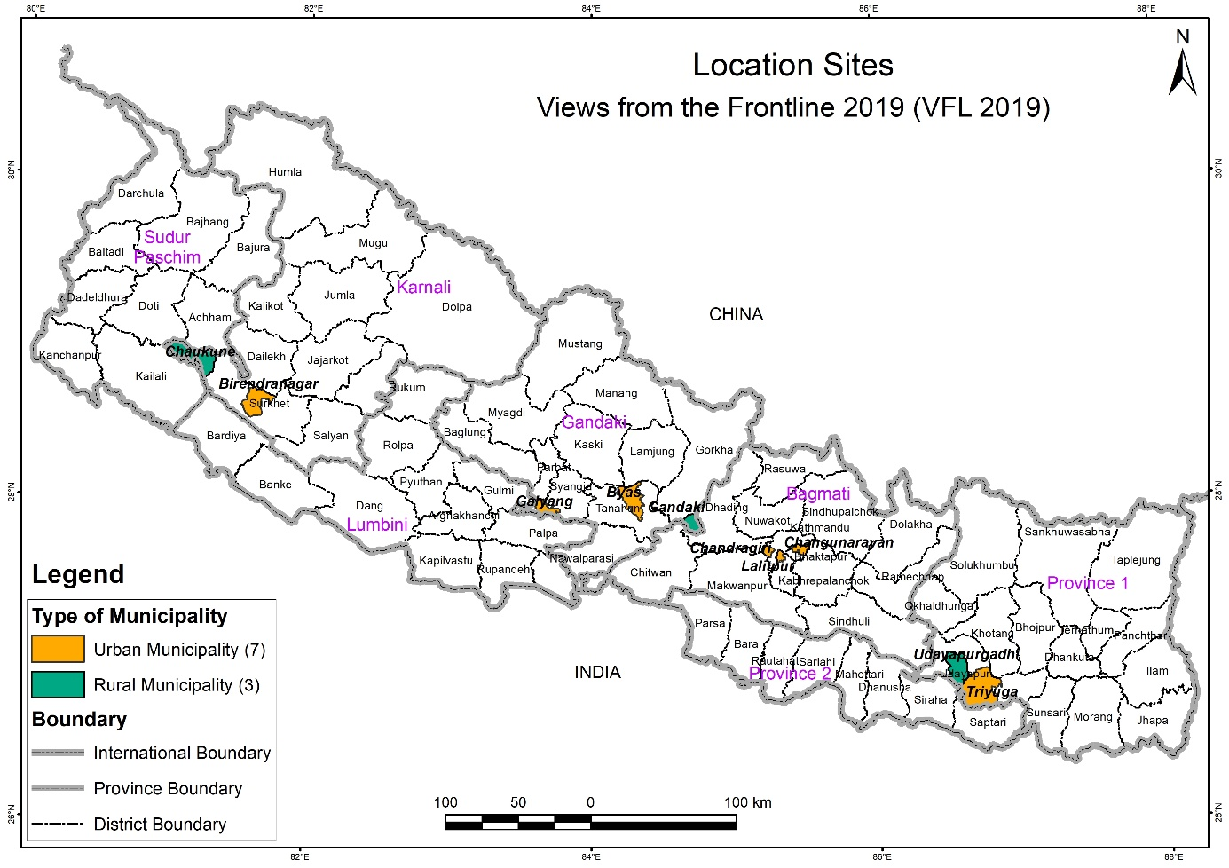

**Figure 1. Map of Nepal with selected municipalities, province and geographical region.**

One active not-for-profit, non-government organization working in the field of disaster risk reduction were selected in each of the four provinces as a partner organization to coordinate the focus group discussions. In communities where the partner organization was not involved directly in any past or present activities, they selected a local civil society organization to assist in the assessment.  Three of the municipalities opted to conduct the survey using their own community volunteers.

### Data Collection

A three-day training program was organized to orient and train two surveyors from each of the local organizations and one responsible person from each of the four coordinating partner organizations. The three-day interactive training program covered introduction, objective, expected outcome and the procedures of the survey. Practice surveying was done on the first half of the last day so that the participants would be able to conduct the survey independently. The authors were involved as instructors in the training program and directly involved in facilitating the practical survey in the communities around the training venue. Further to ensure uniformity of the data, including the collection process, the authors were involved at the initial stage of the survey in all the communities.

In each of the selected communities, the trained surveyors conducted door-to-door survey of randomly selected households) and surveyed representatives of local government, civil society organizations working in the municipality and community consultations. Data collection occurred from April to July 2019.

This article analyzes the risk perception of the 951 individuals that took part in the community consultations in the 10 communities in the Mountain region of Nepal, conducted in the form of focus group discussions. Focus group discussions is a rapid qualitative assessment technique in which a selected set of participants gather to discuss issues and problems (Mondal et. al, 2019). The purpose of the focus group discussion was to collect information about opinions, beliefs, attitudes, perceptions about hazards and risk within groups of people with a similar social characteristic. The goal of the discussion was not to come to consensus or make a decision, but to understand a diversity of perspectives and experiences within that social group. Discussions typically lasted more than three hours and followed a structured set of questions.

There are five parts in the focus group discussion guide. The first part of the guide documented the context, and the interviewer filled the answer without asking the questionnaire to participants. The second part was a local risk profile where questions related to the main risk/threats that community face day to day in the realm of environmental, social, economic and political conditions. The third part was a frontline assessment with questions about the threats and risks and their consequences to the participants. This section also asked about actions carried out by the community and the barriers faced in implementation of these actions to address threats and risks. The fourth part includes queries about local governance on planning, implementation, monitoring and access to information about the projects on threats and risks in the community. The fifth part was filled by the participant regarding any other observations and remarks. This article is generated from the third part of the FGD guide.

A total of 51 focus groups were held in 10 communities, with eight of the focus groups being held with youth and children, 15 being held with women, 15 with men, 8 with seniors, and 5 with people living with disabilities. General demographics about the participants in these focus groups is shared below, with Table 1 summarizing the number of discussions and participants in each community.

**Men FGDs groups.** The largest number of respondents were of the age ranged between 14 to 65 years male group. The majority of men in the communities we held focus group meetings in typically have a high school education or less, with some having no formal education. Two thirds were farmer and the remaining were employed in government services as well as private services. A few were landless agricultural laborers and totally dependents on agriculture. The respondents were of mix ethnic group, with a breakdown of 40% being Braman/Chhetri,45% being Janajati and 14% being Dalit.

**Women FGDs groups.** The second largest respondent were women’s group, age ranged from 25 to 80 years. Most participant had not received formal education and most identified as housewives. In rural areas, females are involved in agriculture either as subsistence farmers or agriculture day laborer. The women’s groups were mix ethnic group including 40% Brahmin/Chhetri, 41% Janajati and 19% Dalit.

**Children and Youth FGDs groups.** Focus groups with children and youth made up 15% of the total participants. Most of the participant were in the age bracket 13-25 years, though a few were as old as 30. In the children and youth groups, 59% of the participants were male and 41% were female. The respondents were of mix ethnic group with a breakdown of 30 % being Brahmin/Chhetri, 53% being Janajati and 17% being Dalit.

**People living with disability FGDs groups.** Among all of the participants of FGD, only 6% were people living with disabilities. Most of the participants in the FGDs were people living with physical disability. Half of the communities did not conduct FGDs because of absence of disability people. Just over a third were age between 25 to 35. In this group 53% were male and 47% were female. Ethnicity wise, 38% were Brahmin/Chhetri, 48% were Janajati and 14% were Dalit.

**Seniors FGDs groups.** Seniors groups represented 16% of the total participants of FGDs. This group was focused on the community member of age above 60 years. Most of them were no longer engaged in wage labor and had retired from government services, private sector services, and farming. Most of the participant had not received formal education. Ethnicity followed a similar pattern as found in the men and women groups. In this group 43% of participants were female and 57% were male.

Table 2. Focus group type, number and participant numbers in Mountain Region communities

|  |  |  |  |  |  |  |
| --- | --- | --- | --- | --- | --- | --- |
| **Risk Area or Community / Focused Group** | **Focused Groups Number (participants numbers)** | | | | | |
| **Women** | **Elderly** | **Children & Youth** | **Men** | **Persons with disability** | **All** |
| Vyas Municipality-1 | 2(21+21) | 1(10) | 1(11) | 1(14) | 1(6) | 6 (83) |
| Chandragiri Municipality-3 | 1(26) | 2(34+10 | 1(15) | 1(20) | 0 | 5(105) |
| Birendranagar Municipality-10 | 1(25) | 1(30) | 1(16) | 2(29+23) | 0 | 5(123) |
| Chaukune R Municipality-10 | 1(15) | 1(29) | 1(22) | 1(16) | 1(14) | 5(94) |
| Udayapurgadhi R Municipality- 5 | 5(21+24+9+13+16 | 0 | 0 | 0 | 0 | 5(83) |
| Gandaki R Municipality- 2 | 1(35) | 1(15) | 1(16) | 1(35) | 1(6) | 5(107) |
| Galyang Municipality- 5 | 1(24) | 0 | 1(24) | 2(31+26) | 1(24) | 5(129) |
| Lalitpur Metropolitan city- 12 | 1(15) | 1(10) | 1(22) | 2(12 +10) | 0 | 5(69) |
| Changunaryan Municipality- 8 | 1(15) | 1(13) | 0 | 2(18+13) | 1(7) | 5(66) |
| Triyuga Municipality- 11 | 1(12) | 0 | 1(20) | 3(20+27+1 | 0 | 5(90) |
| **Grand total** | **15 (292)** | **8 (149)** | **8 (146)** | **15 (305)** | **5 (57)** | **51 (951)** |

+ sign indicates where focus groups include individuals from surrounding communities as well.

# Data Analysis

We analyzed the questions from section II and III of the FGD questionnaires to document the risk perception on various hazards by the different groups. We also examined the response to consequences, priority actions and major barriers on various hazards from the different groups. We used a mixed methods approach to data analysis.

# Results

Community consultations were carried out with women, men, children & youth, people with disabilities, and the elderly. The participants of all the focus groups were community members who do not have a common understanding on terminologies like hazards, risk, threats, disasters etc. At the start of the focus group discussion, a brief explanation of the concept of risk/threats for identification of the main (environmental, social, economic, and political) risks/threats faced by community was discussed. The opening question after the individual introduction and survey purpose was “What are the problems that you are facing on your daily life?” This was a question to stimulate their thinking process. The answers were broadly categorized into social, political, development related and those related to disasters. Then the group was clearer on what did the surveyors wanted to extract form the survey. Then the second question was “What are difficulties and or threats directly related to disasters that you are facing?” These questions drew their interest and they started answering according to their perception and experience.

It was very interesting note that all the groups had more or less common list of risks/threats but there was a great shift in the prioritization and additional threats. Women’s group spelled a set of threats which they have been facing as front liners like early (child) marriage, migration and access to water. The main concern of people with disabilities was accessibility to basic services. Youth and Children group included drug abuse and unemployment as threat, and the men’s group came up with child abuse, exploitation and lack of preparedness. The elderly wanted alcoholism and deforestation as additional threats (Table 3).

Out of 51 FGDs in the mountain region, participants named 35 unique risk/threats. These 35 different risk/threats were mentioned 161 times during the survey. Among these groups, Women recognized 23 unique risks/threats, which was the highest number of any focus group type, followed by 17 from Men, 15 from Children & Youths, 14 from Elderly and 11 from Person with Disability groups. The hazards listed by each focus group type are shown in Table 3.

**Table 3. Risks/Threats listed by social group**

|  |  |
| --- | --- |
| **FGD Social Group Type** | **Risks and Threats** |
| Women (23) | Alcoholism, **Climate Change, Deforestation**, Disease/Epidemics, Drought, **Early marriage**, Earthquakes, Fire, Floods, **Food Insecurity**, Lack of Access to Basic Services, Lack of Access to Water, Landslides, **Migration, Pollution**, **River swelling**, Road Accidents, Storms, **Stray Animals, Tornado**, Traffic Congestion, Violence, Wildlife Attacks |
| Elderly  (14) | Alcoholism, **Crop Damage**, Drought, Earthquakes, Fire, Floods, Hail, **Hurricanes**, Lack of Access to Water, Landslides, Road Accidents, Storms, Unemployment, Wildlife Attacks |
| Children & Youth (15) | Disease/Epidemics, Drought, **Drug Addiction**, Earthquakes, Fire, Floods, Hail, High Cost of Living, Lack of Access to Basic Services, Lack of Access to Water, Landslides, **Poverty**, Road Accidents, Unemployment, Violence |
| Men  (17) | Alcoholism, **Child Abuse and Exploitation**, Disease/Epidemics, Drought, Earthquakes, Fire, Floods, **Heavy Rainfall**, High Cost of Living, Lack of Access to Water, **Lack of Preparedness**, Landslides, Road Accidents, Storms, Traffic Congestion, Unemployment, Wildlife Attacks |
| Persons with disability (11) | Disease/Epidemics, Earthquakes, Floods, Lack of Access to Basic Services, Lack of Access to Water, **Reduction in Irrigation**, Road Accidents, **Temperature Rise**, Unemployment, Violence, Wildlife Attacks |

**Bolded** hazards are not mentioned by other focus groups

Some hazards were mentioned by all social groups, but some are mentioned by only one group. earthquakes, floods, lack of access to water and road accidents were the names of hazards or threats mentioned by all focus groups. Several of these hazards like – climate change, deforestation, early marriage, food insecurity, migration, pollution, river swelling, stray animals and tornado were mentioned by only Women’s groups. Child abuse & exploitation, heavy rainfall, lack of preparedness was mentioned by only the Men’s group. Reduction in irrigation and temperature rise were mentioned only by the people with disabilities group. Drug addiction and poverty were unique threats mentioned by the Children & Youth group. Only Elderly groups mentioned crop damage and hurricanes. These unique hazards are bolded in table 3.

To systematically analyze of the data, we categorized the 35 unique names of hazards into six major groups. These major groups were: Environmental, Infrastructure, Legal, Natural, Natural Common and Social.

The threats and risks as listed by the various focus groups were not confined to disasters alone. The reason behind this is the respondents of the groups do not have clear and common understanding on threats/risk. A simpler and easier questions was phrased to get the problems so that we could select those directly concerned with the risk and threats. Hence the response of the groups covers a broader range which can be combined into several groups. Earthquake, fire, flood, heavy rain, landslides, river swelling are the most common disasters that occurs throughout Nepal and are grouped into “Disasters Common”. Events like hail, hurricane, storms, temperature rise, tornado are sporadic and not so common have been grouped into “Disasters Sporadic”. Similarly, other the problems that the focus groups came up with are clustered into Environmental, Infrastructure, Legal and Social.

The participants were then asked the question “What are the three most significant impacts/consequences these risks/threats have on this community (including on their lives, assets, livelihood, health, environment)?” Through discussion the participants identified which threat they felt was greatest risk/threat, which was the next greatest, and which was the third greatest.

We identified the top three risks/threats for each group using a weighted sum analysis and then normalizing the results by the highest result in each focus group type. First, the three hazards were ranked as Threat#1, Threat#2 and Threat#3 where Threat#1 was the most significant hazard and Threat#3 was of least significance. To consider this relative ranking of hazard based upon significance and importance we used weighted sum analysis method. The weighted sum analysis method is useful to weight and combine multiple inputs to create an integrated analysis (Song and Kang, 2016). Hence, we used this method to combine the frequency of these three ranked threats to a single input variable as weighted score of ranked threats. The weighted score was calculated for each hazard disaggregated by five focus consultation groups. For simplicity, Threat#1, Threat#2 and Threat#3 were given numerical weight as 3, 2 and 1 respectively.

Then, the weighted score of a hazard is calculated as:

|  |  |  |
| --- | --- | --- |
| Weighted Absolute Score | = | (3 X frequency ofThreat#1) + (2 X frequency of Threat#2) + (1 X frequency of Threat#3) |

After calculating a weighted absolute score for each risk/threat participants mentioned, we normalized the absolute score. The term “normalization” in statistics refers to scaling down of data set to make values fall in range between 0 and 1. This allows comparisons of corresponding normalized values among different datasets. It makes the comparisons meaningful by eliminating the effects of the variation in scale of the datasets for example the dataset with large values can be compared with a dataset of smaller values. For this analysis the absolute score of hazards for each group is graded based on the minimum score 0 and the maximum score in the group (Song and Kang, 2016).

|  |  |  |
| --- | --- | --- |
| Relative Score  (in Percentage) | = | (Absolute Score of Hazard in a group/ Highest Score of Hazard in Group) X 100 % |

Table 4 below, is organized by the six major risk groups. It shows each risk/threat identified by participants and the weighted absolute score of each, broken down by each FGD type. The absolute score for each risk when all participants are combined together is shown in the right column. The relative score – showing the relative rank of each risk/threat – is shown in parentheses after each absolute risk score. The top three relative scores are bolded.

**Weighted Absolute Score of Threats/Risk according to Social Groups**

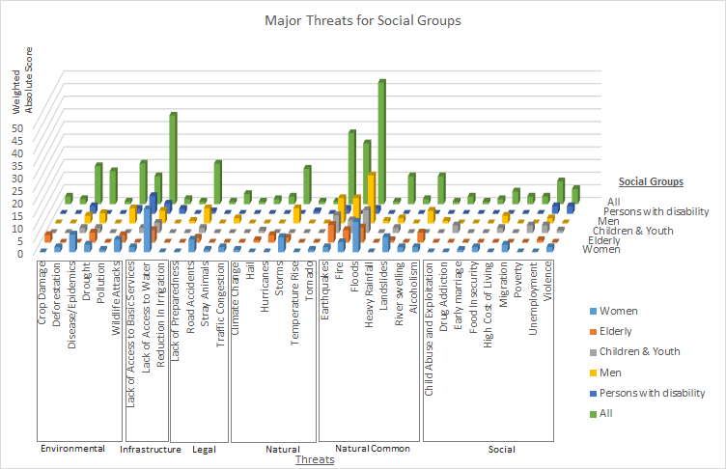

**Interpretation of the major threats/risk according to social groups**

**Table 4: Relative Ranking of Threats/Risk in percentage based upon highest value of weighted absolute score for different community consultation groups.**

|  |  |  |  |  |  |  |  |
| --- | --- | --- | --- | --- | --- | --- | --- |
| SN | Threats | Weighted Absolute Risk Score (Normalized Relative Risk Score) | | | | | |
| Women | Elderly | Children & Youth | Men | Persons with disability | All Social Groups |
| 1 | Environmental | 18 (69%) | 10 (53%) | 4 (17%) | 13 (31%) | 5 (38%) | 50 (44%) |
| 1.1 | Crop Damage | 0 (0%) | 3 (43%) | 0 (0%) | 0 (0%) | 0 (0%) | 3 (6%) |
| 1.2 | Deforestation | 2 (12%) | 0 (0%) | 0 (0%) | 0 (0%) | 0 (0%) | 2 (4%) |
| 1.3 | Disease /Epidemics | 7 (41%) | 0 (0%) | 2 (22%) | 3 (16%) | 3 (43%) | 15 (31%) |
| 1.4 | Drought | 3 (18%) | 4 (57%) | 2 (22%) | 4 (21%) | 0 (0%) | 13 (27%) |
| 1.5 | Pollution | 1 (6%) | 0 (0%) | 0 (0%) | 0 (0%) | 0 (0%) | 1 (2%) |
| 1.6 | Wildlife Attacks | 5 (29%) | 3 (43%) | 0 (0%) | 6 (32%) | 2 (29%) | 16 (33%) |
| 2 | Infrastructure | 19 (73%) | 5 (26%) | 6 (26%) | 5 (12%) | 13 (100%) | 48 (42%) |
| 2.1 | Lack of Access to Basic Services | 2 (12%) | 0 (0%) | 2 (22%) | 0 (0%) | 7 (100%) | 11 (23%) |
| 2,2 | Lack of Access to Water | 17 (100%) | 5 (71%) | 4 (44%) | 5 (26%) | 4 (57%) | *35 (73%)* |
| 2.3 | Reduction in Irrigation | 0 (0%) | 0 (0%) | 0 (0%) | 0 (0%) | 2 (29%) | 2 (4%) |
| 3 | Legal | 8 (31%) | 2 (11%) | 2 (9%) | 9 (21%) | 1 (8%) | 22 (19%) |
| 3.1 | Lack of Preparedness | 0 (0%) | 0 (0%) | 0 (0%) | 1 (5%) | 0 (0%) | 1 (2%) |
| 3.2 | Road Accidents | 5 (29%) | 2 (29%) | 2 (22%) | 6 (32%) | 1 (14%) | *16 (33%)* |
| 3.3 | Stray Animals | 1 (6%) | 0 (0%) | 0 (0%) | 0 (0%) | 0 (0%) | 1 (2%) |
| 3.4 | Traffic Congestion | 2 (12%) | 0 (0%) | 0 (0%) | 2 (11%) | 0 (0%) | 4 (8%) |
| 4 | Natural | 8 (31%) | 6 (32%) | 1 (4%) | 6 (14%) | 1 (8%) | 22 (19%) |
| 4.1 | Climate Change | 1 (6%) | 0 (0%) | 0 (0%) | 0 (0%) | 0 (0%) | 1 (2%) |
| 4.2 | Hail | 0 (0%) | 1 (14%) | 1 (11%) | 0 (0%) | 0 (0%) | 2 (4%) |
| 4.3 | Hurricanes | 0 (0%) | 3 (43%) | 0 (0%) | 0 (0%) | 0 (0%) | 3 (6%) |
| 4.4 | Storms | 6 (35%) | 2 (29%) | 0 (0%) | 6 (32%) | 0 (0%) | 14 (29%) |
| 4.5 | Temperature Rise | 0 (0%) | 0 (0%) | 0 (0%) | 0 (0%) | 1 (14%) | 1 (2%) |
| 4.6 | Tornado | 1 (6%) | 0 (0%) | 0 (0%) | 0 (0%) | 0 (0%) | 1 (2%) |
| 5 | Natural Common | 26 (100%) | 19 (100%) | 23 (100%) | 42 (100%) | 4 (31%) | 114 (100%) |
| 5.1 | Earthquakes | 2 (12%) | 7 (100%) | 7 (78%) | 10 (53%) | 2 (29%) | *28 (58%)* |
| 5.2 | Fire | 4 (24%) | 5 (71%) | 5 (56%) | 10 (53%) | 0 (0%) | 24 (50%) |
| 5.3 | Floods | 12 (71%) | 6 (86%) | 9 (100%) | 19 (100%) | 2 (29%) | *48 (100%)* |
| 5.4 | Heavy Rainfall | 0 (0%) | 0 (0%) | 0 (0%) | 1 (5%) | 0 (0%) | 1 (2%) |
| 5.5 | Landslides | 6 (35%) | 1 (14%) | 2 (22%) | 2 (11%) | 0 (0%) | 11 (23%) |
| 5.6 | River swelling | 2 (12%) | 0 (0%) | 0 (0%) | 0 (0%) | 0 (0%) | 2 (4%) |
| 6 | Social | 10 (38%) | 5 (26%) | 12 (52%) | 11 (26%) | 6 (46%) | 44 (39 %) |
| 6.1 | Alcoholism | 2 (12%) | 4 (57%) | 0 (0%) | 5 (26%) | 0 (0%) | 11 (23%) |
| 6.2 | Child Abuse and Exploitation | 0 (0%) | 0 (0%) | 0 (0%) | 1 (5%) | 0 (0%) | 1 (2%) |
| 6.3 | Drug Addiction | 0 (0%) | 0 (0%) | 3 (33%) | 0 (0%) | 0 (0%) | 3 (6%) |
| 6.4 | Early marriage | 1 (6%) | 0 (0%) | 0 (0%) | 0 (0%) | 0 (0%) | 1 (2%) |
| 6.5 | Food Insecurity | 2 (12%) | 0 (0%) | 0 (0%) | 0 (0%) | 0 (0%) | 2 (4%) |
| 6.6 | High Cost of Living | 0 (0%) | 0 (0%) | 2 (22%) | 3 (16%) | 0 (0%) | 5 (10%) |
| 6.7 | Migration | 3 (18%) | 0 (0%) | 0 (0%) | 0 (0%) | 0 (0%) | 3 (6%) |
| 6.8 | Poverty | 0 (0%) | 0 (0%) | 3 (33%) | 0 (0%) | 0 (0%) | 3 (6%) |
| 6.9 | Unemployment | 0 (0%) | 1 (14%) | 3 (33%) | 2 (11%) | 3 (43%) | 9 (19%) |
| 6.10 | Violence | 2 (12%) | 0 (0%) | 1 (11%) | 0 (0%) | 3 (43%) | 6 (13%) |

When viewing the normalized risk score for all focus groups combined, floods (100%) was the highest ranked risk, followed by lack of access to water (73%), earthquakes (58%) and fire (50%). However, differences in greatest risk/threat emerged across the different social group types.

When the weighted, normalized score for the six major risk/threat groups shown as gray rows in Table 5 are examined, differentiation between social groups is evident. Risks/threats in the Natural Common grouping were the highest priority for all groups except for People with Disability, whose highest risk/threat group was Infrastructure. Concern about infrastructure was also high for women; for this group, Infrastructure risks were their second highest threat group. For Men and Elderly groups, the Environmental risk group was their second priority while the Social category was second highest for the Children & Youth groups as well as the People with Disabilities focus groups.

**Weighted Absolute Score of Categorized Threats according to Social Groups**

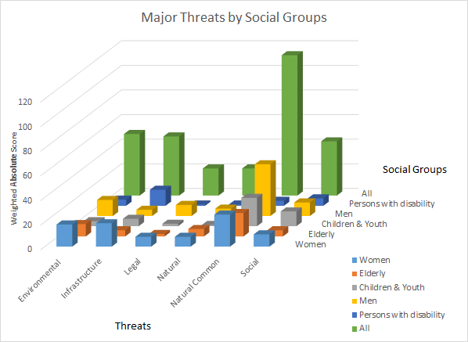

**Table: Weighted Absolute Score**

|  |  |  |  |  |  |  |
| --- | --- | --- | --- | --- | --- | --- |
|  | **Environmental** | **Infrastructure** | **Legal** | **Natural** | **Natural Common** | **Social** |
| **Women** | 18 | **19** | 8 | 8 | **26** | 10 |
| **Elderly** | **10** | 5 | 2 | 6 | **19** | 5 |
| **Children & Youth** | 4 | 6 | 2 | 1 | **23** | **12** |
| **Men** | **13** | 5 | 9 | 6 | **42** | 11 |
| **Persons with disability** | 5 | **13** | 1 | 1 | 4 | **6** |
| **All** | **50** | 48 | 22 | 22 | **114** | 44 |

**Table 5: Top two threat groups by social group (Relative Score)**

|  |  |  |  |  |  |  |
| --- | --- | --- | --- | --- | --- | --- |
| Priority | Women | Elderly | Children & Youth | Men | Persons with disability | All |
| 1st | (100%)  Natural Common | (100%)  Natural Common | (100%)  Natural Common | (100%)  Natural Common | (100%)  Infrast. | (100%)  Natural Common |
| 2nd | (73%)  Infrast. | (53%)  Environ. | (52%)  Social | (31%)  Environ. | (46%)  Social | (44%)  Environ. |

Looking deeper at the ranking of specific hazards by each focus group type, differences in top ranked risks/threats emerges. The Women FDGs indicated their first priority was lack of access to water. Interestingly, lack of access to water was not a high priority for any other group. Lack of access to basic services was the topmost threat to people with disabilities, but not even mentioned once by the Elderly or Men’s groups. Children and youth along with the Men’s group ranked flood as the first threat and the Elderly groups took earthquake as their first threat. The top four prioritized threats of each focus group are presented in Table 8.

**Table 6: Top Four Threats according to Social Group Type (Relative Score)**

|  |  |  |  |  |  |  |
| --- | --- | --- | --- | --- | --- | --- |
|  | **Women** | **Elderly** | **Children & Youth** | **Men** | **Persons with disability** | **All** |
| 1st | (100%)  Lack of Access to Water | (100%)  Earthquakes | (100%)  Floods | (100%)  Floods | (100%)  Lack of Access to Basic Services | (100%) Floods |
| 2nd | (71%)  Floods | (86%)  Floods | (78%) Earthquakes | (53%) Earthquakes, Fire | (57%)  Lack of Access to Water | (73%) Lack of Access to Water |
| 3rd | (41%)  Disease/Epidemics | (71%)  Fire, Lack of Access to Water | (56%)  Fire | (32%)  Road Accidents, Storms, Wildlife  Attacks | (43%) Disease/Epidemics, Unemployment, Violence | (58%) Earthquakes |
| 4th | (35%)  Landslides, Storms | (57%)  Alcoholism, Drought | (44%)  Lack of Access to Water | (26%)  Alcoholism, Lack of Access to Water | (29%)  Earthquakes, Floods, Reduction in Irrigation, Wildlife Attacks | (50%) Fire |

## Consequences, Barriers and Actions of Major Threats by Social Groups

The first row of table 6 was selected as major threats concerned for each focused group. Then consequences, barriers and actions of those major threats were analyzed. Participants were asked to list three consequences of a threat as shown in Part III of Annex 1. Similarly three barriers and three actions were listed for each threat they identified in the survey. The frequency of consequences, actions and barriers of a threat listed by a particular group were calculated by simply counting the number of times the consequences, actions and barriers repeated for that threat by that particular group.

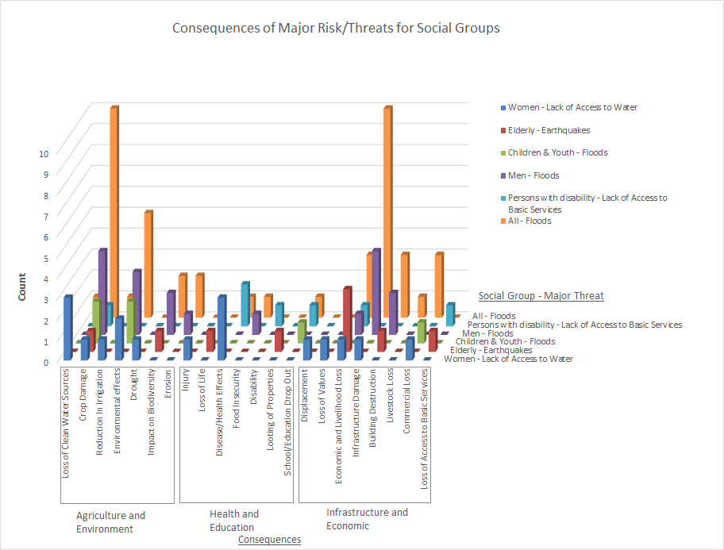

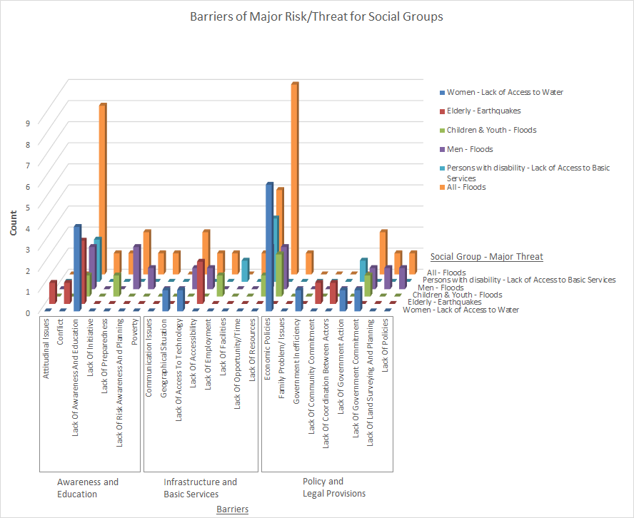

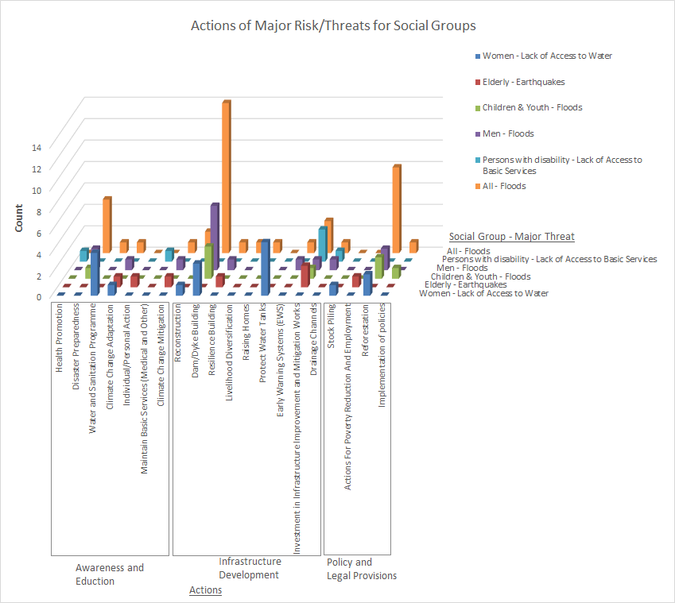

## Table 7: Consequences Actions and Barriers of Major Threats

|  |  |  |  |
| --- | --- | --- | --- |
| **Focus Group - Major Threat** | **Consequences (Count)** | **Barriers (Count)** | **Actions (Count)** |
| Women - Lack of Access to Water | Commercial Loss (1), Crop Damage (1), Disease/Health Effects (3), Displacement (1), Drought (1), Economic and Livelihood Loss (1), Environmental effects (2), Infrastructure Damage (1), Injury (1), Loss of Clean Water Sources (3), Loss of Values (1), Reduction In Irrigation (1) | Economic Policies (6), Geographical Situation (1), Government Inefficiency (1), Lack Of Access To Technology (1), Lack Of Awareness And Education (4), Lack Of Government Action (1), Lack Of Government Commitment (1), Water Pollution (1) | Awareness Raising Education and Training (1), Climate Change Adaptation (1), Dam/Dyke Building (3), Protect Water Tanks (5), Reconstruction (1), Reforestation (2), Stock Piling (1), Water and Sanitation Programme (4) |
| Elderly - Earthquakes | Building Destruction (1), Crop Damage (1), Economic and Livelihood Loss (3), Impact on Biodiversity (1), Looting of Properties (1), Loss of Access to Basic Services (1), Loss of Life (1) | Attitudinal Issues (1), Conflict (1), Lack Of Accessibility (2), Lack Of Awareness And Education (3), Lack Of Community Commitment (1), Lack Of Coordination Between Actors (1) | Actions For Poverty Reduction And Employment (1), Awareness Raising Education and Training (2), Climate Change Adaptation (1), Climate Change Mitigation (1), Individual/Personal Action (1), Investment in Infrastructure Improvement and Mitigation Works (2), Resilience Building (1) |
| Children & Youth - Floods | Commercial Loss (1), Crop Damage (2), Environmental effects (2), Flooding (1), School/Education Drop Out (1) | Economic Policies (2), Lack Of Awareness And Education (1), Lack Of Employment (1), Lack Of Government Commitment (1), Lack Of Preparedness (1), Lack Of Resources (1) | Dam/Dyke Building (3), Disaster Preparedness (1), Implementation of policies (1), Investment in Infrastructure Improvement and Mitigation Works (1), Reforestation (2) |
| Men - Floods | Building Destruction (2), Crop Damage (4), Economic and Livelihood Loss (1), Environmental effects (3), Erosion (1), Food Insecurity (1), Impact on Biodiversity (2), Infrastructure Damage (4) | Economic Policies (2), Lack Of Access To Technology (1), Lack Of Accessibility (1), Lack Of Awareness And Education (2), Lack Of Government Commitment (1), Lack Of Land Surveying And Planning (1), Lack Of Policies (1), Lack Of Resources (2), Lack Of Risk Awareness And Planning (2), Poverty (1) | Awareness Raising Education and Training (1), Climate Change Adaptation (1), Climate Change Mitigation (1), Dam/Dyke Building (6), Disaster Preparedness (2), Drainage Channels (1), Early Warning Systems (EWS) (1), Investment in Infrastructure Improvement and Mitigation Works (1), Reforestation (2), Resilience Building (1) |
| Persons with disability - Lack of Access to Basic Services | Crop Damage (1), Disability (1), Disease/Health Effects (2), Economic and Livelihood Loss (1), Loss of Access to Basic Services (1), School/Education Drop Out (1) | Lack Of Awareness And Education (2), Lack Of Facilities (1), Lack Of Government Action (1), Lack Of Resources (3) | Awareness Raising Education and Training (1), Drainage Channels (1), Health Promotion (1), Investment in Infrastructure Improvement and Mitigation Works (3), Maintain Basic Services (Medical and Other) (1) |
| All - Floods | Building Destruction (3), Commercial Loss (3), Crop Damage (10), Disease/Health Effects (1), Economic and Livelihood Loss (3), Environmental effects (5), Erosion (2), Flooding (1), Food Insecurity (1), Impact on Biodiversity (2), Infrastructure Damage (10), Livestock Loss (1), Loss of Clean Water Sources (1), Reduction In Irrigation (1), School/Education Drop Out (1) | Communication Issues (1), Economic Policies (9), Family Problem/ Issues (1), Lack Of Access To Technology (2), Lack Of Accessibility (1), Lack Of Awareness And Education (8), Lack Of Employment (1), Lack Of Government Commitment (2), Lack Of Initiative (1), Lack Of Land Surveying And Planning (1), Lack Of Opportunity/Time (1), Lack Of Policies (1), Lack Of Preparedness (1), Lack Of Resources (4), Lack Of Risk Awareness And Planning (2), Poverty (1) | Awareness Raising Education and Training (3), Climate Change Adaptation (1), Climate Change Mitigation (1), Dam/Dyke Building (14), Disaster Preparedness (5), Drainage Channels (1), Early Warning Systems (EWS) (1), Implementation of policies (1), Investment in Infrastructure Improvement and Mitigation Works (3), Livelihood Diversification (1), Raising Homes (1), Reconstruction (2), Reforestation (8), Resilience Building (1), Water and Sanitation Programme (1) |

We categorized the Consequences, Barriers and Actions of Major Threats Identified by the different focus groups into broad headings as shown in the following table

|  |  |  |
| --- | --- | --- |
| **Consequences Related to** | **Barriers Related to** | **Actions** |
| Agriculture and Environment | Awareness and education | Awareness and education |
| Health and Education | Physical development | Physical development |
| Infrastructure and Economic | Policy and legal provision | Policy formulation |

The grouped list of Consequences, Barriers and Actions for major Threats Identified by the different focus groups are presented in the following three tables

1. **Categorization of Consequences**

|  |  |
| --- | --- |
| **Categories related to** | **Consequences** |
| Agriculture and Environment | Flooding |
| Crop Damage |
| Drought |
| Environmental effects |
| Erosion |
| Impact on Biodiversity |
| Loss of Clean Water Sources |
| Reduction In Irrigation |
| Health and Education | Disability |
| Disease/Health Effects |
| Food Insecurity |
| Injury |
| Looting of Properties |
| Loss of Life |
| School/Education Drop Out |
| Infrastructure and Economic Development  (Physical Development) | Building Destruction |
| Commercial Loss |
| Displacement |
| Economic and Livelihood Loss |
| Infrastructure Damage |
| Livestock Loss |
| Loss of Access to Basic Services |
| Loss of Values |

1. **Categorization of Barriers**

|  |  |
| --- | --- |
| **Categories related to** | **Barriers** |
| Awareness and Education | Water Pollution |
| Attitudinal Issues |
| Conflict |
| Lack Of Awareness And Education |
| Lack Of Initiative |
| Lack Of Preparedness |
| Lack Of Risk Awareness And Planning |
| Poverty |
| Infrastructure and Basic Services  (Physical Development) | Communication Issues |
| Geographical Situation |
| Lack Of Access To Technology |
| Lack Of Accessibility |
| Lack Of Employment |
| Lack Of Facilities |
| Lack Of Opportunity/Time |
| Lack Of Resources |
| Policy and Legal Provisions | Economic Policies |
| Family Problem/ Issues |
| Government Inefficiency |
| Lack Of Community Commitment |
| Lack Of Coordination Between Actors |
| Lack Of Government Action |
| Lack Of Government Commitment |
| Lack Of Land Surveying And Planning |
| Lack Of Policies |

1. **Categorization of Actions**

|  |  |
| --- | --- |
| **Categories** | **Actions** |
| Awareness and Education | Awareness Raising Education and Training |
| Climate Change Adaptation |
| Climate Change Mitigation |
| Disaster Preparedness |
| Health Promotion |
| Individual/Personal Action |
| Maintain Basic Services (Medical and Other) |
| Water and Sanitation Program |
| Infrastructure and Development  (Physical Development) | Dam/Dyke Building |
| Drainage Channels |
| Early Warning Systems (EWS) |
| Investment in Infrastructure Improvement and Mitigation |
| Livelihood Diversification |
| Protect Water Tanks |
| Raising Homes |
| Reconstruction |
| Resilience Building |
| Policy and Legal Provision | Actions For Poverty Reduction And Employment |
| Implementation of policies |
| Reforestation |
| Stock Piling |

## 

## Table 8: Score of categorized consequences, actions and barriers for major threat identified by each group

|  |  |  |  |  |  |  |  |  |  |
| --- | --- | --- | --- | --- | --- | --- | --- | --- | --- |
|  | **Consequences** | | | **Barriers** | | | **Actions** | | |
| **Group - Major Threat** | **Infrastructure and Economic** | **Health and Education** | **Agriculture and Environment** | **Policy and Legal Provisions** | **Awareness and Education** | **Infrastructure and Basic Services** | **Policy and Legal Provision** | **Infrastructure and Development** | **Awareness and Education** |
| **Women -  Lack of Access to Water** | 5 | 4 | 8 | 9 | 4 | 2 | 3 | 9 | 6 |
| **Elderly -  Earthquakes** | 5 | 2 | 2 | 2 | 5 | 2 | 1 | 3 | 5 |
| **Children & Youth -  Floods** | 1 | 1 | 4 | 3 | 2 | 2 | 3 | 4 | 1 |
| **Men -  Floods** | 7 | 1 | 10 | 5 | 5 | 4 | 2 | 10 | 5 |
| **Persons with disability -  Lack of Access to Basic Services** | 2 | 4 | 1 | 1 | 2 | 4 | 0 | 4 | 3 |
| **All -  Floods** | 20 | 3 | 21 | 14 | 13 | 10 | 9 | 24 | 11 |

## Natural Common Disaster comparison with Historical Data

Finally, an assessment of historic disaster impacts in the selected communities of Mountain Region was performed. The National Society for Earthquake Technology – Nepal (NSET) is organizing natural disaster data since 1971 as DesInventar data. The historical data of selected communities from mountain region related to natural disaster was extracted from the database. From 1971 to 2019, major natural hazard events were flood, storm, fire, landslide, earthquake and epidemic respectively (Table 8) in the 10 communities of Mountain region where focus group discussions were held. In these communities, flood had the greatest impact, affecting over 15 thousand people and causing over a thousand houses to be destroyed and more than 100 deaths. Storm had affected about 2 thousand people, but caused no injury, houses destruction or death. The least people were affected by epidemic in these communities; the data do not include Covid-19 pandemic impacts.

**Table 7: Historical data on some major threats and impacts in the 10 mountain region communities**

|  |  |  |  |  |
| --- | --- | --- | --- | --- |
| **Major Threats** | **Affected People** | **Injured People** | **House Destroyed** | **Deaths** |
| Flood | 15,173 | 9 | 1,176 | 147 |
| Storm | 2,246 | 0 | 0 | 0 |
| Fire | 1,714 | 66 | 255 | 39 |
| Landslide | 1,231 | 1 | 147 | 15 |
| Earthquake | 270 | 3 | 50 | 0 |
| Epidemic | 32 | 16 | 0 | 27 |

# Discussion

* Since the mountain region of Nepal is elevated land structure with gentle to steep topography, landslide and flood are the common disaster. Similarly, the mountain of Nepal was formed with collision between Tibetan and Indian plate, earthquakes are also one of the common disasters. Historical data show that flood, storm, fire, landslide and earthquake have affected the study site villages in the past, with floods, fire and landslides causing housing destruction and death. In the sites studied, earthquakes have not caused death, but large-scale earthquakes in Nepal have had high mortality.

When residents of the 10 study sites were asked about the risks and threats of concern, these common natural hazards were the highest priority of Women’s, Men’s, Child and Youth, and Elderly FGD groups. These groups were especially concerned about flood, earthquake and fire. However, the People with Disabilities FGD groups placed these common natural hazards as a much lower concern; for them, earthquake and flood were ranked forth, and even then, was tied with animal attacks and reduced irrigation (Table 6). Thus, current tracking of the impacts of natural hazards could be used as a proxy for risk ranking among most social groups, but does not represent the primary concerns of People with Disabilities. A focus on natural hazards also does not capture the primary concern of Women’s groups, which ranked access to water as their top concern, even though natural hazards were the second, third and fourth ranked concern.

The prioritization of threat reflects the activities in which each social group is directly involved. For instance, women normally take the responsibility of acquiring water for the family. In dry periods, women's drudgery increases as they have to walk a long distance to fill a water canister, and also have to face risking their life while fetching water from dug wells (Gurung et al., 2019). Given the burden of water collection that falls to many Nepali women in the mountain region, it is natural that they would rank access to water as their first. Water collection is a concern 365 days a year, whereas disasters are only periodic. Rama Dahal, women participant in FGD says, - “I am the only women at home to carry water and it takes 1 hour daily to bring water once. In the mean time I have to prepare food and my children and husband for school and office at early morning. This has been so difficult for me to manage.

Similarly, the topmost problem for persons with disability was accessibility to basic services. A 2018 survey of 400 people with disabilities found that only 16% had a monthly income (Samarajiva, 2018). 6% were self-employed without employees, 4% self-employed with employees, 3% were employed, and 0.3% were unemployed but seeking a job (Samarajiva, 2018). They too have to face this difficulty 365 days a year, a much more frequent problem than floods, earthquakes, landslides and fire that may happen once a year or even less frequently. Ramsaran Thapa, person with disability participant in FGD says, - “We merely get chance of employment, and unemployment and disability make us burden to our family members.”

Children and youth along with the men see flood as their top threat perhaps because neither group have is routinely tasked with accessing water and these groups may have the highest access to basic services among the social groups. The other reason for these two groups to rank flood as the top threat may be because in Nepal children, youth, and men often go out of home on daily basis. Nepalese children and youth need to cross river with the help of Wire Bridge (Tuin in Nepali) and cables to attain school or to do outdoor work which is most dangerous during flood. Children and youth and men both the groups travel to and from school, employment, or even shopping, which is difficult during floods. Due to the flood disaster in many schools closed, the infrastructures damaged, drop out of the students increased which ultimately impacts on the performance of the students (Chaudhary and Timsina, 2017). Hari Karki, school student participant in Children and Youth FGD says, - “During the monsoon time, we have to miss the classes due to flood either on the way to school or sometime ground floor of school get drown so we cannot run the classes. These three-month sometime leads many of us to drop out from school.”

Many elderly people have difficulty with movement and they may see earthquake as the top threat because they want to rush out of the building during an earthquake. Shyam Bahadur Bista, participant in Elderly FGD says, - “We are aged and we cannot move quickly, at least thin people can be carried by one person and move but fat like us may drag other family member also in danger. They cannot live us alone and we cannot help ourself.” Around 8.1 per cent of Nepal’s population are aged 60 and over. “It is thought most of the residents in the areas close to where the earthquake struck are older men and women and children, as the younger populations have left to find work”, said Toby Porter, Chief Executive Officer at HelpAge International ([www.helpage.org](http://www.helpage.org)).

Interestingly, the historical data on landslide risk threats does not coincide with the threats that the groups have prioritized. Four social groups, except persons with disabilities, listed landslide as one of the risks they faced. However, only women have ranked landslide within their top four concerns. This difference may be the result of several factors. While the historical data is a collective mean of the 10 municipalities, the focus groups were more concerned about the situations in their respective community. These communities are typically dense settlements, taking up only a small portion of the land cover in the municipality. Landslides, while prevalent in the municipality, may be happening outside the bounds of the community settlement. In fact, none of the respondents of the focus groups have experienced landslides.

# Conclusions and Implications

NEED A CONCLUSION PARAGRAH HERE.

Disaster management organizations tend to track and care about natural hazards but when we talk to residents, development, infrastructure and social risks are equally important to them. Furthermore, when disaster management focuses on natural hazard risk reduction, as well as response to natural hazard disasters, they may not be addressing what women and people with disabilities see as their greatest threats. As such, disaster management organizations should consider working more closely with development and human rights groups to broaden their impact and to collaborate with those who are addressing the risks and threats of marginalized groups in society.

Following this ranking, participants identified priority action required to reduce those impact/consequences of the risk. “What are the three priority actions that this community can take against these risks/threats?”. Third step was identification of the main barriers to take the priority action. “What are the three most significant barriers to these actions being implemented?”

**References**

Assar, M. (1971), Guide to sanitation in natural Disasters, Geneva, World Health Organization.

Ghimire, T. (2019). Issue of Federal System in Nepal. *Tribhuvan University Journal*, *33*(1), 155-166. https://doi.org/10.3126/tuj.v33i1.28690

Fordham, M. (2006a). Unpublished Field Notes: El Salvador 2006, for Plan International

Hines, R.I. (2007). Natural disasters and gender inequalities: The 2004 Tsunami and the case of India. Race, Gender, and class: volume 14, Number 1-2, 60-65p.

Lunga, W., Bongo, P.P., Van Niekerk, D. & Musarurwa, C., 2019, ‘Disability and disaster risk reduction as an incongruent matrix: Lessons from rural Zimbabwe’, Jàmbá: Journal of Disaster Risk Studies 11(1), a648. http://doi:10.4102/jamba.v11i1.648

Meder, B., Le Lec, F., & Osman, M. (2013). Decision making in uncertain times: what can cognitive and decision sciences say about or learn from economic crises? Trends in Cognitive Sciences, 17, 257–260.

Mondal, M., Akter, S., & Khan, A S M., Anwar, M., and Prodhan, Z. (2019). Focus Group Discussion.

Owen, James (2005). “Tsunami Family Saved by Schoolgirl’s Geography Lesson.” National Geographic News, January 18.

Oxfam (2005). ‘The Tsunami’s Impact on women’, Oxfam Briefing Note, Oxfam International, available at <http://www.preventionweb.net/files/1502_bn050326tsunamiwomen.pdf>

Panampitiya, W.M.G.N. (2019), A Review of Importance of Gender Mainstreaming in Disaster Risk Reduction. International Journal of Research and Innovation in Social Science (IJRISS) |Volume III, Issue VIII, 59-63 p.

Peek, L. (2008). Children and disasters: Understanding vulnerability, developing capacities, and promoting resilience. Children, Youth and Environments, 18(1), 1-29p.

Peek, L and Stough, L.M (2010). Children with disabilities in the context of disaster: A social vulnerability perspective. Child Development, Vol.81, No. 4, 1260-1270p.

Pidgeon, N. F., Hood, C., Jones, D., Turner, B., & Gibson, R. (1992). Risk perception. In Risk analysis, perception and management: Report of a Royal Society study group (pp. 89–134). London, England: Royal Society

Rolleri, L.A. (2013), Understanding Gender and Gender Equality, Gender and Sexual Health part one, Act for Youth Centre of Excellence, Research Facts and Findings, New York, Cornell University, University of Rochester, and New York State Center for School Safety.

Scotti, J. R., Stevens, S., Cavender, A., Morford, M., Jacoby, V., Freed, R., et al. (2007). Response of persons with mental retardation/developmental disabilities to emergency situation: Implications for disaster preparedness. Paper presented at the annual meeting of the International Society for Traumatic Stress Studies, Baltimore.

Sena L. and Woldemichael K. (2006), Disaster Prevention and Preparedness, Ethiopia Public Health Training Initiative, The Carter Center, the Ethiopia Ministry of Health, and the Ethiopia Ministry of Education.

Sjöberg, L., Moen, B.-E., & Rundmo, T. (2004). Explaining risk perception: An evaluation of the psychometric paradigm in risk perception research. Trondheim, Norway: Rotunde

Song B. and Kang S. (2016). A method of Assigning weights using a Ranking and Nonhierarchy comparison. Advances in decision sciences published by Hindwai publishing corporation, vol. 2016, article id. 8963214, 9 pages. [doi.org/10.1155/2016/8963214](https://doi.org/10.1155/2016/8963214)

Twigg, J. (2007), Tools for mainstreaming disaster risk reduction, social impact assessment, International Federation of Red cross and Red Crescent societies prevention consortium.

UNISDR (United Nations International Strategy for Disaster Reduction), 2009. UNISDR terminology on disaster risk reduction. Geneva: UNISDR. 30 p.

Wisner B, Gaillard JC, Kelman I 2012. Framing disaster: theories and stories seeking to understand hazards, vulnerability and risk. In: Wisner B, Gaillard JC, Kilman I eds. Handbook of hazards and disaster risk reduction. London, Routledge. Pp. 18–34

UNDRR (United Nations Disaster Risk Reduction), 2018. Words into Action guideline: Man-made and Technological Hazard, United Nations Office for Disaster Risk Reduction. 84p.

Samarajiva, R. (2018). ICT access and use by Persons with Disabilities (PWD) in Nepal. After Access.

Gurung A, Adhikari S, Chauhan R, Thakuri S, Nakarmi S, Ghale S, Dongol B S, and Rijal D, 2019. Water crises in a water-rich country: case studies from rural watersheds of Nepal's mid-hills. Water Policy (2019) 21 (4): 826–847.

Chaudhary G, and Timsina T P, 2017. Impact of Flood on Performance of Students: The Case of Secondary School Students in Jaleshwor Municipality, Mahottari. Journal of Advanced Academic Research (JAAR) ISSN: 2362-1303 (Paper) | eISSN: 2362-1311(Online)

Website visited

<https://www.undrr.org/publication/words-action-guideline-man-made/technological-hazards>

<http://www.preventionweb.net/files/7817_UNISDRTerminologyEnglish.pdf>.

<https://www.gndr.org/programmes/views-from-the-frontline.html>

**Annex**

# Annex 1. Views from the Frontline Community Consultation Discussion Guide

PART I – CONTEXT

Fields 1-11 can be filled out by interviewer without asking the participants.

|  |  |  |  |  |  |  |  |  |  |  |  |  |
| --- | --- | --- | --- | --- | --- | --- | --- | --- | --- | --- | --- | --- |
| 1 | Name of the Enumerator |  | | | | | | | | | | |
| 2 | Partner Organization |  | | | | | | | | | | |
| 3 | National Coordinating Organization (NCO) |  | | | | | | | | | | |
| 4 | Country |  | | | | | | | | | | |
| 5 | Risk Area |  | | | | | | | | | | |
| 6 | Urban/Rural |  | | | | | | | | | | |
| 7 | Location (Province) |  | | | | | | | | | | |
| 8 | City/Municipality/District |  | | | | | | | | | | |
| 9 | Name of Community |  | | | | | | | | | | |
| 10 | Survey Date |  | | | | | | | | | | |
| 11 | Survey Reference Number |  | | | | | | | | | | |
| 12 | Consultation Group of: | Men | Women | | Children & Youth | | | | Elderly | | Persons  with  disability | |
| 13 | Number of Participants in Survey Group |  | | | | | | | | | | |
| 14 | Informant Age (how many participants per age group | 14-17 | | 18-24 | | 25-34 | | 35 -44 | | 45-64 | | 65+ |
| 15 | Previous VFL participation (by show of  hands) | None | | VFL 2009 | | VFL 2011 | | VFL 2013 | | Frontline | | |
| 16 | Have there been any community-led  interventions in your community to reduce disaster risks? | YES | | | | | NO | | | | | |

PART II – LOCAL RISK PROFILE:

Ask the participants, what are main risks/threats (environmental, social, economic and political) that they face in their community:

|  |
| --- |
| Main risks/threats: |

Ask the participants to suggest where the risks/threats listed above should be placed on the Frequency- Impact Matrix below.

Frequency Impact Matrix

|  |  |  |  |  |
| --- | --- | --- | --- | --- |
| Impacts | Frequency | | | |
| Rarely (once in every 2+ years) | Often (at least once in a year) | Very Often (at least once in six months) | Always (at least once in a month) |
| Very Strong Impact |  |  |  |  |
| Strong Impact |  |  |  |  |
| Some Impact |  |  |  |  |
| Little Impact |  |  |  |  |

Part III – Frontline Assessment

Use the following questions to complete three tables below:

|  |  |
| --- | --- |
| Risks/Threats | What are the three most significant risks/threats that this community faces? |
| Impacts/Consequences | What are the three most significant impacts/consequences these risks/threats have on this community (including on their lives, assets, livelihood, health, environment)? |
| Actions | What are the three priority actions that this community can take against these risks/threats? |
| Barriers | What are the three most significant barriers to these actions being implemented? |

|  |  |  |  |
| --- | --- | --- | --- |
| Risk/Threat #1 | 3 most significant Consequences | 3 priority Actions | 3 most significant Barriers |
|  |  |  |  |
|  |  |  |  |
|  |  |  |  |
| Risk/Threat #2 | 3 most significant Consequences | 3 priority Actions | 3 most significant Barriers |
|  |  |  |  |
|  |  |  |  |
|  |  |  |  |

|  |  |  |  |
| --- | --- | --- | --- |
| Risk/Threat #3 | 3 most significant Consequences | 3 priority Actions | 3 most significant Barriers |
|  |  |  |  |
|  |  |  |  |
|  |  |  |  |

Loss Trends: In this community, how have disaster losses (lives, assets, livelihoods etc) changed in the last 5-10 years? (write down the number of participants in each column)

|  |  |  |  |  |
| --- | --- | --- | --- | --- |
| 01 | 02 | 03 | 04 | 05 |
| Decreased significantly | Decreased a little | Remained the same | Increased a little | Increased significantly |
|  |  |  |  |  |

Forecasting: What are the three most significant risks/threats you think the younger generations will face when they grow up? (the risks/threats may remain the same as the ones they are facing now)

|  |  |
| --- | --- |
| 1 |  |
| 2 |  |
| 3 |  |

Part IV – Inclusive Risk Governance and Enabling Environment:

Ask the participants to answer the following questions using a scale of one to five:

|  |  |  |  |  |
| --- | --- | --- | --- | --- |
| 01 | 02 | 03 | 04 | 05 |
| Not at all | To a very limited extent | Occasionally | Yes, with some limitations | Yes, very effectively |

|  |  |  |  |  |  |  |  |  |
| --- | --- | --- | --- | --- | --- | --- | --- | --- |
| Indicator  Number | Category | Question | | Number of Participants | | | | |
| CC1 | Assessment | Does local government regularly talk to your community, including the most vulnerable, to assess the most significant risks/threats? | | 1 | 2 | 3 | 4 | 5 |
| CC2 | Planning (a) | Does your local government talk to your community, including the most vulnerable, when preparing policies, plans and actions to address risks/threats? | | 1 |  |  |  |  |
| CC3 | Planning (b) | Do you find your local development plan takes into account the risks your community faces? | |  |  |  |  |  |
| CC4 | Implementation | Does your local government involve your community, including the most vulnerable, in the implementation of actions to reduce risks/threats? | |  |  |  |  |  |
| CC5 | Monitoring | Are there processes for you/your community to easily raise concerns or complaints to local government about the actions to reduce risks/threats? | |  |  |  |  |  |
| CC6 | Access to Information | Can you access information from your local government about the actions to reduce risks/threats? | |  |  |  |  |  |
| CC7 | Access to  resources | Can you access financial resources (money, material, equipment) from your local government to address risks/threats? | |  |  |  |  |  |
| CC8 | Factors impacting inclusion | What are three most significant factors preventing and facilitating your inclusion in decision-making processes about the risks/threats in your community? (e.g. timing, cost and accessibility to input) | |  |  |  |  |  |
|  |  | Factors preventing your inclusion | Factors facilitating your inclusion |  |  |  |  |  |
|  |  | 1 | 1 |  |  |  |  |  |
|  |  | 2 | 2 |  |  |  |  |  |
|  |  | 3 | 3 |  |  |  |  |  |
| CC9 | Coherence (a) | Have the impacts of the disasters increased in your communities due to public or private development projects?  Space for notes: | |  |  |  |  |  |
| CC10 | Coherence (b) | Have your ecosystems (such as wetlands, forests etc) been impacted due to development? | |  |  |  |  |  |
| CC11 | Coherence (c) | Do you think that the environment/ecosystem issues are considered when implementing development plans? | |  |  |  |  |  |
| CC12 | Coherence (d) | Do ecosystems contribute to protecting your community against hazards? | |  |  |  |  |  |
| CC13 | Coherence (e) | Are the risks and approaches to reduce these risks considered carefully in public and private investment projects that affect your community? | |  |  |  |  |  |

**PART V – CONCLUSION:** Use the space below to note any other observations and remarks.

Observation/Remarks (not to be included in database):

|  |
| --- |
|  |

**Annex 2. Data Tables**

|  |  |  |  |  |  |
| --- | --- | --- | --- | --- | --- |
|  | Women (46) | Elderly (26) | Children & Youth (27) | Men (45) | Persons with disability (17) |
| Threats (FGDs Count) | Lack of Access to Water(6) | Earthquakes(3) | Floods(4) | Floods(8) | Lack of Access to Basic Services(3) |
| Floods(5) | Floods(3) | Earthquakes(3) | Fire(6) | Floods(2) |
| Fire(4) | Lack of Access to Water(3) | Fire(3) | Earthquakes(5) | Lack of Access to Water(2) |
| Disease/Epidemics(3) | Alcoholism(2) | Disease/Epidemics(2) | Alcoholism(3) | Unemployment(2) |
| Landslides(3) | Drought(2) | Lack of Access to Water(2) | Lack of Access to Water(3) | Disease/Epidemics(1) |
| Storms(3) | Fire(2) | Poverty(2) | Road Accidents(3) | Earthquakes(1) |
| Drought(2) | Road Accidents(2) | Road Accidents(2) | Storms(3) | Reduction In Irrigation(1) |
| Road Accidents(2) | Storms(2) | Drought(1) | Drought(2) | Road Accidents(1) |
| Violence(2) | Crop Damage(1) | Drug Addiction(1) | Unemployment(2) | Temperature Rise(1) |
| Wildlife Attacks(2) | Deforestation(1) | Hail(1) | Wildlife Attacks(2) | Violence(1) |
| Alcoholism(1) | Hail(1) | High Cost of Living(1) | Child Abuse and Exploitation(1) | Wildlife Attacks(1) |
| Climate Change(1) | Hurricanes(1) | Lack of Access to Basic Services(1) | Disease/Epidemics(1) |  |
| Deforestation(1) | Landslides(1) | Landslides(1) | Heavy Rainfall(1) |  |
| Early marriage(1) | Unemployment(1) | Unemployment(1) | High Cost of Living(1) |  |
| Earthquakes(1) | Wildlife Attacks(1) | Violence(1) | Lack of Preparedness(1) |  |
| Food Insecurity(1) |  |  | Landslides(1) |  |
| Lack of Access to Basic Services(1) |  |  | Poverty(1) |  |
| Migration(1) |  |  | Traffic Congestion(1) |  |
| Pollution(1) |  |  |  |  |
| River swelling(1) |  |  |  |  |
| Stray Animals(1) |  |  |  |  |
| Tornado(1) |  |  |  |  |
| Traffic Congestion(1) |  |  |  |  |
| Unemployment(1) |  |  |  |  |

**Annex 3: Ranking of Threats Full Dataset**

|  |  |  |  |  |  |  |  |
| --- | --- | --- | --- | --- | --- | --- | --- |
| SN | Threats | [Ranked Threats Count] Absolute Score (Relative Percentage) | | | | | |
| Women | Elderly | Children & Youth | Men | Persons with disability | All Social Groups |
| 1 | Environmental | [2T1, 5T2, 2T3] 18 (69%) | [2T1, 2T2, 0T3] 10 (53%) | [0T1, 1T2, 2T3] 4 (17%) | [4T1, 0T2, 1T3] 13 (31%) | [1T1, 1T2, 0T3] 5 (38%) | [9T1, 9T2, 5T3] 50 (44%) |
| 1.1 | Crop Damage | [0T1, 0T2, 0T3] 0 (0%) | [1T1, 0T2, 0T3] 3 (43%) | [0T1, 0T2, 0T3] 0 (0%) | [0T1, 0T2, 0T3] 0 (0%) | [0T1, 0T2, 0T3] 0 (0%) | [1T1, 0T2, 0T3] 3 (6%) |
| 1.2 | Deforestation | [0T1, 1T2, 0T3] 2 (12%) | [0T1, 0T2, 0T3] 0 (0%) | [0T1, 0T2, 0T3] 0 (0%) | [0T1, 0T2, 0T3] 0 (0%) | [0T1, 0T2, 0T3] 0 (0%) | [0T1, 1T2, 0T3] 2 (4%) |
| 1.3 | Disease/Epidemics | [1T1, 2T2, 0T3] 7 (41%) | [0T1, 0T2, 0T3] 0 (0%) | [0T1, 0T2, 2T3] 2 (22%) | [1T1, 0T2, 0T3] 3 (16%) | [1T1, 0T2, 0T3] 3 (43%) | [3T1, 2T2, 2T3] 15 (31%) |
| 1.4 | Drought | [0T1, 1T2, 1T3] 3 (18%) | [0T1, 2T2, 0T3] 4 (57%) | [0T1, 1T2, 0T3] 2 (22%) | [1T1, 0T2, 1T3] 4 (21%) | [0T1, 0T2, 0T3] 0 (0%) | [1T1, 4T2, 2T3] 13 (27%) |
| 1.6 | Famine | [0T1, 0T2, 0T3] 0 (0%) | [0T1, 0T2, 0T3] 0 (0%) | [0T1, 0T2, 0T3] 0 (0%) | [0T1, 0T2, 0T3] 0 (0%) | [0T1, 0T2, 0T3] 0 (0%) | [0T1, 0T2, 0T3] 0 (0%) |
| 1.7 | Pollution | [0T1, 0T2, 1T3] 1 (6%) | [0T1, 0T2, 0T3] 0 (0%) | [0T1, 0T2, 0T3] 0 (0%) | [0T1, 0T2, 0T3] 0 (0%) | [0T1, 0T2, 0T3] 0 (0%) | [0T1, 0T2, 1T3] 1 (2%) |
| 1.8 | Wildlife Attacks | [1T1, 1T2, 0T3] 5 (29%) | [1T1, 0T2, 0T3] 3 (43%) | [0T1, 0T2, 0T3] 0 (0%) | [2T1, 0T2, 0T3] 6 (32%) | [0T1, 1T2, 0T3] 2 (29%) | [4T1, 2T2, 0T3] 16 (33%) |
| 2 | Infrastructure | [5T1, 2T2, 0T3] 19 (73%) | [0T1, 2T2, 1T3] 5 (26%) | [0T1, 3T2, 0T3] 6 (26%) | [1T1, 0T2, 2T3] 5 (12%) | [3T1, 1T2, 2T3] 13 (100%) | [9T1, 8T2, 5T3] 48 (42%) |
| 2.1 | Lack of Access to Basic Services | [0T1, 1T2, 0T3] 2 (12%) | [0T1, 0T2, 0T3] 0 (0%) | [0T1, 1T2, 0T3] 2 (22%) | [0T1, 0T2, 0T3] 0 (0%) | [2T1, 0T2, 1T3] 7 (100%) | [2T1, 2T2, 1T3] 11 (23%) |
| 2,2 | Lack of Access to Water | [5T1, 1T2, 0T3] 17 (100%) | [0T1, 2T2, 1T3] 5 (71%) | [0T1, 2T2, 0T3] 4 (44%) | [1T1, 0T2, 2T3] 5 (26%) | [1T1, 0T2, 1T3] 4 (57%) | [7T1, 5T2, 4T3] 35 (73%) |
| 2.3 | Reduction In Irrigation | [0T1, 0T2, 0T3] 0 (0%) | [0T1, 0T2, 0T3] 0 (0%) | [0T1, 0T2, 0T3] 0 (0%) | [0T1, 0T2, 0T3] 0 (0%) | [0T1, 1T2, 0T3] 2 (29%) | [0T1, 1T2, 0T3] 2 (4%) |
| 3 | Legal | [1T1, 2T2, 1T3] 8 (31%) | [0T1, 0T2, 2T3] 2 (11%) | [0T1, 0T2, 2T3] 2 (9%) | [1T1, 2T2, 2T3] 9 (21%) | [0T1, 0T2, 1T3] 1 (8%) | [2T1, 4T2, 8T3] 22 (19%) |
| 3.2 | Lack of Preparedness | [0T1, 0T2, 0T3] 0 (0%) | [0T1, 0T2, 0T3] 0 (0%) | [0T1, 0T2, 0T3] 0 (0%) | [0T1, 0T2, 1T3] 1 (5%) | [0T1, 0T2, 0T3] 0 (0%) | [0T1, 0T2, 1T3] 1 (2%) |
| 3.3 | Road Accidents | [1T1, 1T2, 0T3] 5 (29%) | [0T1, 0T2, 2T3] 2 (29%) | [0T1, 0T2, 2T3] 2 (22%) | [1T1, 1T2, 1T3] 6 (32%) | [0T1, 0T2, 1T3] 1 (14%) | [2T1, 2T2, 6T3] 16 (33%) |
| 3.4 | Stray Animals | [0T1, 0T2, 1T3] 1 (6%) | [0T1, 0T2, 0T3] 0 (0%) | [0T1, 0T2, 0T3] 0 (0%) | [0T1, 0T2, 0T3] 0 (0%) | [0T1, 0T2, 0T3] 0 (0%) | [0T1, 0T2, 1T3] 1 (2%) |
| 3.5 | Traffic Congestion | [0T1, 1T2, 0T3] 2 (12%) | [0T1, 0T2, 0T3] 0 (0%) | [0T1, 0T2, 0T3] 0 (0%) | [0T1, 1T2, 0T3] 2 (11%) | [0T1, 0T2, 0T3] 0 (0%) | [0T1, 2T2, 0T3] 4 (8%) |
| 4 | Natural | [1T1, 1T2, 3T3] 8 (31%) | [1T1, 1T2, 1T3] 6 (32%) | [0T1, 0T2, 1T3] 1 (4%) | [0T1, 3T2, 0T3] 6 (14%) | [0T1, 0T2, 1T3] 1 (8%) | [2T1, 5T2, 6T3] 22 (19%) |
| 4.1 | Climate Change | [0T1, 0T2, 1T3] 1 (6%) | [0T1, 0T2, 0T3] 0 (0%) | [0T1, 0T2, 0T3] 0 (0%) | [0T1, 0T2, 0T3] 0 (0%) | [0T1, 0T2, 0T3] 0 (0%) | [0T1, 0T2, 1T3] 1 (2%) |
| 4.2 | Hail | [0T1, 0T2, 0T3] 0 (0%) | [0T1, 0T2, 1T3] 1 (14%) | [0T1, 0T2, 1T3] 1 (11%) | [0T1, 0T2, 0T3] 0 (0%) | [0T1, 0T2, 0T3] 0 (0%) | [0T1, 0T2, 2T3] 2 (4%) |
| 4.3 | Hurricanes | [0T1, 0T2, 0T3] 0 (0%) | [1T1, 0T2, 0T3] 3 (43%) | [0T1, 0T2, 0T3] 0 (0%) | [0T1, 0T2, 0T3] 0 (0%) | [0T1, 0T2, 0T3] 0 (0%) | [1T1, 0T2, 0T3] 3 (6%) |
| 4.4 | Storms | [1T1, 1T2, 1T3] 6 (35%) | [0T1, 1T2, 0T3] 2 (29%) | [0T1, 0T2, 0T3] 0 (0%) | [0T1, 3T2, 0T3] 6 (32%) | [0T1, 0T2, 0T3] 0 (0%) | [1T1, 5T2, 1T3] 14 (29%) |
| 4.5 | Temperature Rise | [0T1, 0T2, 0T3] 0 (0%) | [0T1, 0T2, 0T3] 0 (0%) | [0T1, 0T2, 0T3] 0 (0%) | [0T1, 0T2, 0T3] 0 (0%) | [0T1, 0T2, 1T3] 1 (14%) | [0T1, 0T2, 1T3] 1 (2%) |
| 4.6 | Tornado | [0T1, 0T2, 1T3] 1 (6%) | [0T1, 0T2, 0T3] 0 (0%) | [0T1, 0T2, 0T3] 0 (0%) | [0T1, 0T2, 0T3] 0 (0%) | [0T1, 0T2, 0T3] 0 (0%) | [0T1, 0T2, 1T3] 1 (2%) |
| 5 | Natural Common | [5T1, 3T2, 5T3] 26 (100%) | [5T1, 1T2, 2T3] 19 (100%) | [5T1, 3T2, 2T3] 23 (100%) | [8T1, 6T2, 6T3] 42 (100%) | [0T1, 2T2, 0T3] 4 (31%) | [23T1, 15T2, 15T3] 114 (100%) |
| 5.1 | Earthquakes | [0T1, 1T2, 0T3] 2 (12%) | [2T1, 0T2, 1T3] 7 (100%) | [2T1, 0T2, 1T3] 7 (78%) | [2T1, 1T2, 2T3] 10 (53%) | [0T1, 1T2, 0T3] 2 (29%) | [6T1, 3T2, 4T3] 28 (58%) |
| 5.2 | Fire | [0T1, 0T2, 4T3] 4 (24%) | [1T1, 1T2, 0T3] 5 (71%) | [0T1, 2T2, 1T3] 5 (56%) | [0T1, 4T2, 2T3] 10 (53%) | [0T1, 0T2, 0T3] 0 (0%) | [1T1, 7T2, 7T3] 24 (50%) |
| 5.3 | Floods | [4T1, 0T2, 0T3] 12 (71%) | [2T1, 0T2, 0T3] 6 (86%) | [3T1, 0T2, 0T3] 9 (100%) | [6T1, 0T2, 1T3] 19 (100%) | [0T1, 1T2, 0T3] 2 (29%) | [15T1, 1T2, 1T3] 48 (100%) |
| 5.4 | Heavy Rainfall | [0T1, 0T2, 0T3] 0 (0%) | [0T1, 0T2, 0T3] 0 (0%) | [0T1, 0T2, 0T3] 0 (0%) | [0T1, 0T2, 1T3] 1 (5%) | [0T1, 0T2, 0T3] 0 (0%) | [0T1, 0T2, 1T3] 1 (2%) |
| 5.5 | Landslides | [1T1, 1T2, 1T3] 6 (35%) | [0T1, 0T2, 1T3] 1 (14%) | [0T1, 1T2, 0T3] 2 (22%) | [0T1, 1T2, 0T3] 2 (11%) | [0T1, 0T2, 0T3] 0 (0%) | [1T1, 3T2, 2T3] 11 (23%) |
| 5.6 | River swelling | [0T1, 1T2, 0T3] 2 (12%) | [0T1, 0T2, 0T3] 0 (0%) | [0T1, 0T2, 0T3] 0 (0%) | [0T1, 0T2, 0T3] 0 (0%) | [0T1, 0T2, 0T3] 0 (0%) | [0T1, 1T2, 0T3] 2 (4%) |
| 6 | Social | [1T1, 2T2, 3T3] 10 (38%) | [0T1, 2T2, 1T3] 5 (26%) | [3T1, 1T2, 1T3] 12 (52%) | [1T1, 3T2, 2T3] 11 (26%) | [1T1, 1T2, 1T3] 6 (46%) | [6T1, 9T2, 8T3] 44 (39%) |
| 6.1 | Alcoholism | [0T1, 1T2, 0T3] 2 (12%) | [0T1, 2T2, 0T3] 4 (57%) | [0T1, 0T2, 0T3] 0 (0%) | [0T1, 2T2, 1T3] 5 (26%) | [0T1, 0T2, 0T3] 0 (0%) | [0T1, 5T2, 1T3] 11 (23%) |
| 6.2 | Child Abuse and Exploitation | [0T1, 0T2, 0T3] 0 (0%) | [0T1, 0T2, 0T3] 0 (0%) | [0T1, 0T2, 0T3] 0 (0%) | [0T1, 0T2, 1T3] 1 (5%) | [0T1, 0T2, 0T3] 0 (0%) | [0T1, 0T2, 1T3] 1 (2%) |
| 6.3 | Drug Addiction | [0T1, 0T2, 0T3] 0 (0%) | [0T1, 0T2, 0T3] 0 (0%) | [1T1, 0T2, 0T3] 3 (33%) | [0T1, 0T2, 0T3] 0 (0%) | [0T1, 0T2, 0T3] 0 (0%) | [1T1, 0T2, 0T3] 3 (6%) |
| 6.4 | Early marriage | [0T1, 0T2, 1T3] 1 (6%) | [0T1, 0T2, 0T3] 0 (0%) | [0T1, 0T2, 0T3] 0 (0%) | [0T1, 0T2, 0T3] 0 (0%) | [0T1, 0T2, 0T3] 0 (0%) | [0T1, 0T2, 1T3] 1 (2%) |
| 6.5 | Food Insecurity | [0T1, 1T2, 0T3] 2 (12%) | [0T1, 0T2, 0T3] 0 (0%) | [0T1, 0T2, 0T3] 0 (0%) | [0T1, 0T2, 0T3] 0 (0%) | [0T1, 0T2, 0T3] 0 (0%) | [0T1, 1T2, 0T3] 2 (4%) |
| 6.6 | High Cost of Living | [0T1, 0T2, 0T3] 0 (0%) | [0T1, 0T2, 0T3] 0 (0%) | [0T1, 1T2, 0T3] 2 (22%) | [1T1, 0T2, 0T3] 3 (16%) | [0T1, 0T2, 0T3] 0 (0%) | [1T1, 1T2, 0T3] 5 (10%) |
| 6.7 | Migration | [1T1, 0T2, 0T3] 3 (18%) | [0T1, 0T2, 0T3] 0 (0%) | [0T1, 0T2, 0T3] 0 (0%) | [0T1, 0T2, 0T3] 0 (0%) | [0T1, 0T2, 0T3] 0 (0%) | [1T1, 0T2, 0T3] 3 (6%) |
| 6.8 | Poverty | [0T1, 0T2, 0T3] 0 (0%) | [0T1, 0T2, 0T3] 0 (0%) | [1T1, 0T2, 0T3] 3 (33%) | [0T1, 0T2, 0T3] 0 (0%) | [0T1, 0T2, 0T3] 0 (0%) | [1T1, 0T2, 0T3] 3 (6%) |
| 6.9 | Unemployment | [0T1, 0T2, 0T3] 0 (0%) | [0T1, 0T2, 1T3] 1 (14%) | [1T1, 0T2, 0T3] 3 (33%) | [0T1, 1T2, 0T3] 2 (11%) | [0T1, 1T2, 1T3] 3 (43%) | [1T1, 2T2, 2T3] 9 (19%) |
| 6.10 | Violence | [0T1, 0T2, 2T3] 2 (12%) | [0T1, 0T2, 0T3] 0 (0%) | [0T1, 0T2, 1T3] 1 (11%) | [0T1, 0T2, 0T3] 0 (0%) | [1T1, 0T2, 0T3] 3 (43%) | [1T1, 0T2, 3T3] 6 (13%) |